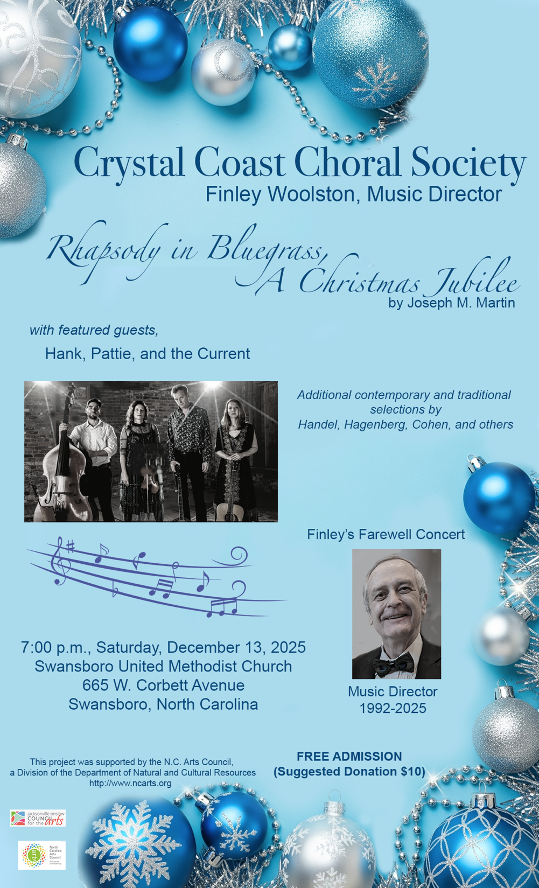
x
Dues Round Up ($5 - $49)
Ed Binanay Melissa Ann Bolling Sally Burner Beth Canepa
Alice Cundiff Cindy Erexson Judy Fitzpatrick Karin Glander
Chris Harker Larry Hughes Dave Johnson Paul Koons
Maria Lundgren Eric Myers Richard Montfort LaVera Parato
James Parato Debra Pylypiw Lynn Rouse Peggy Scott
Frances Sutton Olivia Taylor Mike Thorn Julia Thorn
Ann Van Hoorn Lesley Vereen Sandra Yankwich

Auction Donations
Pam Perkins Julia Wax, Emerald Isle Realty Hampton Inn
Ethan Johnson, Pogie’s Fishing & Kayak Center. Carolina Home & Garden
Kris Stumpf, Wines for Humanity Vann Fine Art Portraits
Thank you to all choral members who donated basket items

Scholarship Donations
Pamela Stewart, $250, In memory of David Stewart
Laurel Zmoda, $50 In honor of Barney Zmoda on his 100th birthday and in memory of Marilyn Zmoda

Scholarship Donations in honor of Finley Woolston
Jeanine & Mark Johnson, $500
East Carolina Musical Arts Education Foundation, $500
Julia & Michael Thorn, $200 Nancy Willis, $100
Donna Winkler, $100 Jon Shaw, $100
Kirk & Nanette Jones, $80 Sylvia & David Schultz, $60
Lynn Rouse, $50 Beth & Matt Maun, $50
Carol Scull, $50 Shirley & Paul LeBoeuf, $50
James & LaVera Parato, $50 Allen & Chris Harker, $50
Debra Pylypiw, $50 Sheryl Woodbury, $35
Brenda Haun $30 Frances Sutton, $25
Diana Hannon, $25 Terry Gibb, $25
Mary Mathusek, $25 Paul Koons, $20
Sheila Portela, $20 Ann VonHoorn, $20
Anonymous Members of Chorus, $138

We also acknowledge the generous contributions from the NC Council for the Arts.


PROGRAM of MUSIC
Part I
Host and Masters of Ceremonies
Bobbi Edge
Reverend Elias Ballew,
Swansboro United Methodist Church

Go Where I Send Thee arr. By Paul Caldwell & Sean Ivory All Praise to Thee Elaine Hagenberg Star in the East Southern Harmony, 1845
Christmas Hallelujah Music by Leonard Cohen, Christmas Lyrics by Finley Woolston
Hallelujah, from Messiah G. F. Handel, edited by Joe Hickman

INTERMISSION AND INTRODUCTION OF NEW MUSIC DIRECTOR

Part II
Music by Hank, Pattie, and the Current

Part III
Rhapsody in Bluegrass: A Christmas Jubilee
Joseph M. Martin
Narrator
Reverend Laura Thompson, Swansboro United Methodist Church

Hear the Wondrous Story

The King Shall Come - Sylvia Schultz, Soprano Solo

Star of Promise, Light of Glory

A Morning Star will Rise
Are you interested in singing with the Crystal Coast Choral Society?

We’re an adult community chorus dedicated to presenting choral music to the highest standard. Although we don’t require an audition, we do require that our members have a pleasant singing voice, be able to match pitch to sing in the appropriate voice section and be willing to practice outside of weekly rehearsals. If you would like further information, see our website at crystalcoastchoralsociety.org. Spring rehearsal begins on January 6. Membership application is at https://www.crystalcoastchoralsociety.org/join

FINANCIAL SUPPORT
Many individuals, businesses, and organizations have contributed to the Crystal Coast Choral Society. We gratefully acknowledge the following donations made since our last concert:

Impresario ($1000 and above)
Lloyd and Melanie Mattingly, Pinnacle Storage

Maestro ($500 - $999)
Swansboro United Methodist Church Jeanine & Mark Johnson

Virtuoso ($250 - $499)
Carteret-Craven EMC Jones-Onslow EMC Team Chevrolet of Swansboro Tom & Kathy Dewkett Wayne Schriever
Chapel by the Sea Singers, In memory of Charlton Breeden
Della Knight, The Pool & Patio Store
Courtney Pelly, In honor of Lesley Vereen and Mary Mathusek

Patron ($50 - $249)
Cindy Erexson Jo Anne West Lesley Vereen
Elaine Hughes Shelley Myott, In honor of Cindy Erexson
LaVera & James Parato, In memory of Richard White & Joe Stroud
Karen Zvornes, In memory of Joe Stroud
Jimmie & Claire Smith, In memory of Joe Stroud

musicianship, friendship, dedication, hard work, amazing good humor and love made each rehearsal a joy and every concert a special sharing of the tremendous power of music for good. It has been a true honor and indeed a privilege to be trusted with the leadership of such a fine musical family for so many years.

A special acknowledgement is due to our loyal audience over the years. Some have seldom missed a concert, and for others this may be their first. I’ve often said that without an audience it’s just a rehearsal. When we share our music with an audience it becomes the joining of individual spirits into the one joint spirit through the sublime sounds of the singing human voice.

I have every confidence that the Crystal Coast Choral Society will continue to provide the highest quality choral music for Eastern North Carolina under the direction of my friend and new Music Director, Dr. Ayumi Nakamae. I look forward to being in the audience at all future concerts.

ACKNOWLEDGMENTS

Special thanks and deep appreciation for the Board of Directors of the Crystal Coast Choral Society. Their untiring work behind the scenes makes possible all the concerts we present.

A very sincere thanks to Swansboro United Methodist Church for many years of continued support and use of their facilities for rehearsals and performances.

A heartfelt thank you goes to all the singers in the Choral Society. Their musicianship, friendship, love of singing, hard work, and good humor form a very special bond of love and musical family. Without them, there would be silence; with them there is music, that most sublime of gifts.

A very special thanks to you, the members of our audience. We appreciate you sharing your evening or afternoon and our love of singing with us. Without you, it’s just a rehearsal. With you, it’s a concert.

For information about supporting the Crystal Coast Choral Society through donations or business sponsorship, go to our website at crystalcoastchoralsociety.org


Donations are happily accepted by cash, checks made payable to Crystal Coast Choral Society, or by Paypal donation at https://www.crystalcoastchoralsociety.org/donate

Mary Went A-Riding
LaVera Parato, Soprano Solo
Michelle Johnson, Pam Stewart, Maria Lundgren – Descant Soprani

O Little Town
Lindsay Williams, Soprano Solo

Here Comes the Light

A Christmas Answer
Ed Binanay, Tenor Solo
Lindsay Williams and Pam Stewart, Soprano Duet

A Little Light Was Born
Debra Pylypiw, Alto Solo
Michelle Johnson, Pam Stewart, Maria Lundgren – Descant Soprani

CONCERT DEDICATION
Finley would like to dedicate his final concert as Music Director to the memory of his older sister, Mary Helen. The only times she heard him sing were when he returned to Nebraska for a family funeral. She was excited to be making plans to be here tonight but passed away unexpectedly.

This concert is also being presented in memory of Nanci McGarvey, longtime Choral Society member who passed this season.
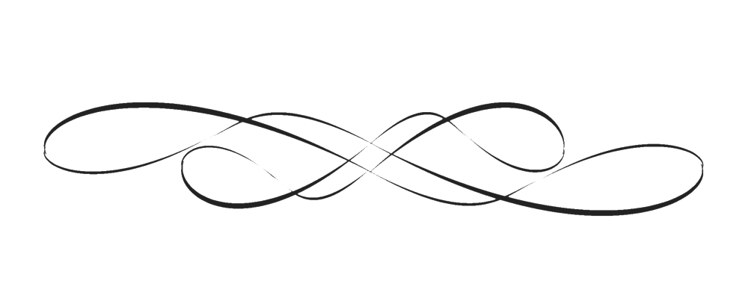

CRYSTAL COAST CHORAL SOCIETY

SOPRANO
*Melissa Ann Bolling Susan Davis
Diana Hannon Brenda Haun *Michelle Johnson
Shannon Lanier Shirley Le Boeuf Maria Lundgren
Mary Mathusek *Beth Maun LaVera Parato
Sylvia Schultz *Peggy Scott Carol Scull
Pam Stewart *Erin Vereen Ann VonHoorn
*Judy Wallace Lindsay Williams Sheryl Woodbury

ALTO
Mary Helen Casey *Alice Cundiff *Kathy Dewkett
*Cindy Erexson *Judy Fitzpatrick Pam Fortney
Terry Gibb Karin Glander Chris Harker
Jeanine Jackson *Nanette Jones Melissa Kenward Meredith McDonald Shelia Portela *Lynn Rouse
*Frances Sutton Olivia Taylor *Julia Y. Thorn
Nancy J. Willis Donna Winkler

TENOR
Edward Binanay Beth Canepa Charlene Heckathorn Linda Mitchell Richard Montfort Eric Myers
Jim Parato *Debra Pylypiw David Schultz
Steven Robert Stump II *Mike Thorn Sandra Yankwich

BASS
*Larry Hughes Dave Johnson Kirk Jones
Paul Koons Michael McGinn Jim Norman
*Bruce Wallace
*Member of the Choral Society Board of Directors

Accompanist – Teresa Boykin

The Crystal Coast Choral Society would like to thank Finley Woolston for his 33 years of steadfast support of the CCCS. He has tirelessly planned concert seasons accompanied by hours and hours of score study. He has sought out talented instrumentalists to add their talents to our concerts. He has worked diligently to recruit new members. He has looked for ways to expand singing opportunities for our members from local events like the Mullet Festival, Beirut Memorial Ceremony, Emerald Isle Christmas Parade to events further afield at Lincoln Center and Carnegie Hall in New York and even to Germany. Perhaps most importantly, he has supported all of us as a friend – celebrating the good times and grieving with us in the sad times. We will truly miss him and sincerely wish him the best!

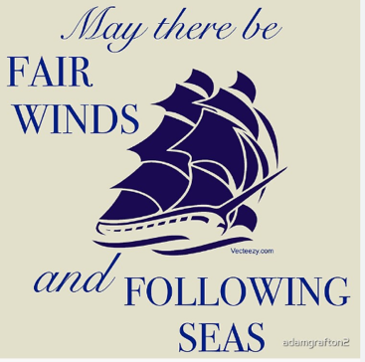

MUSIC DIRECTOR GREETING AND FAREWELL

In 1989 I was in the U.S. Navy serving with the Marine Corps at Camp LeJeune. I was also an experienced choral singer looking to join an accomplished community chorus. A friend from church recommended the Crystal Coast Choral Society and I started singing with them as soon as possible. It was a wonderful and welcoming chorus. I retired from the Navy and attended UNC Wilmington as a vocal performance major. In 1992 the Choral Society founder, Delbert Bowles, wanted to retire and asked me to assume the duties as Music Director. I was honored to be asked and accepted. That was 33 years ago, and I now find myself in the same position as Delbert in 1992: it’s time to retire and pass the baton to a new Music Director.

The passage of time can be deceptive: those 33 years seem to have slipped by in the blink of an eye. In my memory each year is full of glorious music performed by wonderful friends who shared my love of singing. Many of those friends are no longer with us but in my memory I still hear their voices that enriched my life. The singers in the current chorus are the latest in a long line of choral musicians whose talent,

